Title
Design and Development of a Web-Based Mamagan Fun & Adventure Beach Resort Online Booking and Payment System with Gcash Integration

1. System Description
The Mamagan Fun & Adventure Beach Resort Online Booking and Payment System is a web-based platform that allows tourists to browse beach resorts, check real-time availability of facilities (cabanas, day beds, jet skis, island tours), and book their preferred date and time slot online. The system eliminates manual reservation logbooks, overbooking, and long queues by providing live inventory updates and instant confirmation. Guests can complete payments securely using PayMongo, which supports GCash, Maya, GrabPay, and credit cards in one seamless checkout.
After successful payment, the system automatically generates a digital QR ticket and sends it via email and SMS. Resort staff use an admin dashboard to manage facilities, update rates and promos, block dates for maintenance or private events, view all bookings, confirm guest arrival, and generate revenue reports. The system is designed to improve customer experience, increase resort revenue through prepaid bookings, and streamline daily resort operations.

2. Actors / Users
- Guest (Tourist): Primary end-user who browses, books, pays, and manages reservations
- Resort Staff (Admin): Resort manager/employee who manages inventory, pricing, bookings, and reports
- PayMongo Payment Gateway (External System): Processes payments and provides webhook confirmation
- System Administrator (Optional): Oversees platform-wide configuration, user accounts, and maintenance

3. Main System Functions
- User registration and secure login
- Browse resorts and view facility details (photos, rates, descriptions)
- Check real-time availability by date and time
- Create, view, and cancel bookings
- Secure online payment via PayMongo (GCash/Maya/GrabPay/Card)
- Automatic generation and delivery of digital QR tickets
- Admin management of facilities, rates, promos, and blocked dates
- Admin check-in/arrival confirmation using QR tickets
- Revenue and occupancy reporting for resort owners

4. UML Diagram (Use Case Diagram – Required)
Chosen UML Diagram: Use Case Diagram (with proper UML 2.5 notation, clearly labeled actors, include/extend relationships)
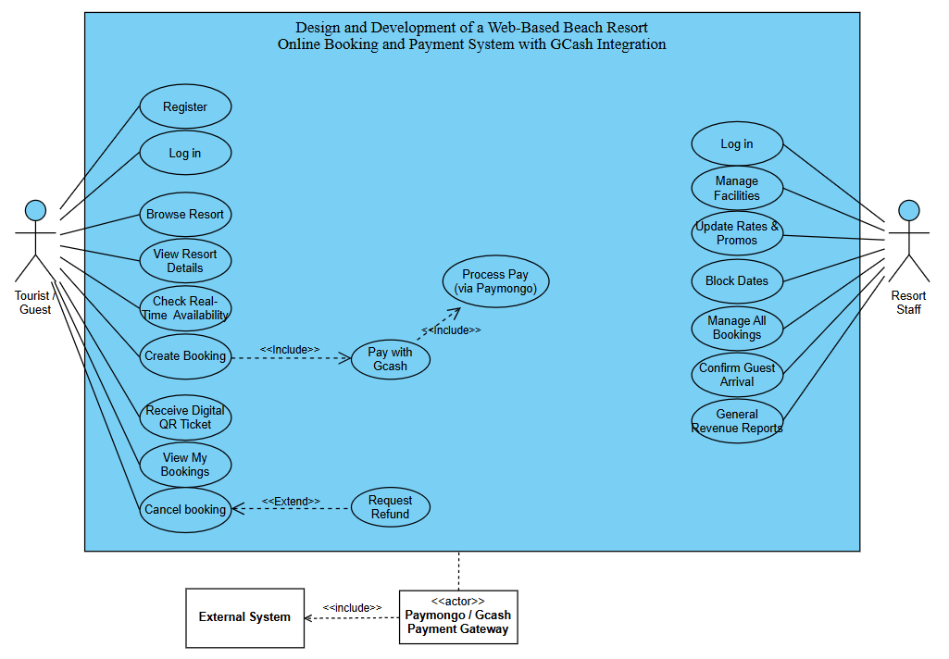

Relationship Explanation (UML Correct)
- Solid lines: Actors → use cases (Guest performs booking; Staff performs admin functions)
- «include» (dashed arrow): Create Booking → Pay with GCash/Maya/Card (payment is mandatory) and Pay with GCash/Maya/Card → Process Payment (PayMongo) (uses external gateway)
- «extend» (dashed arrow): Cancel Booking → Refund Process (refund occurs only when cancellation policy allows it)

